How to access the teams recordings of GEN AI BATCH 2026

Step 1 : Search for teams app

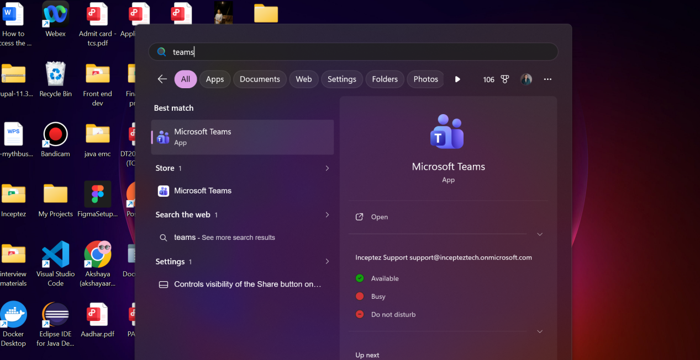

Step 2 : Click on the teams icon left side and then click the Team name GEN AI BATCH 2026

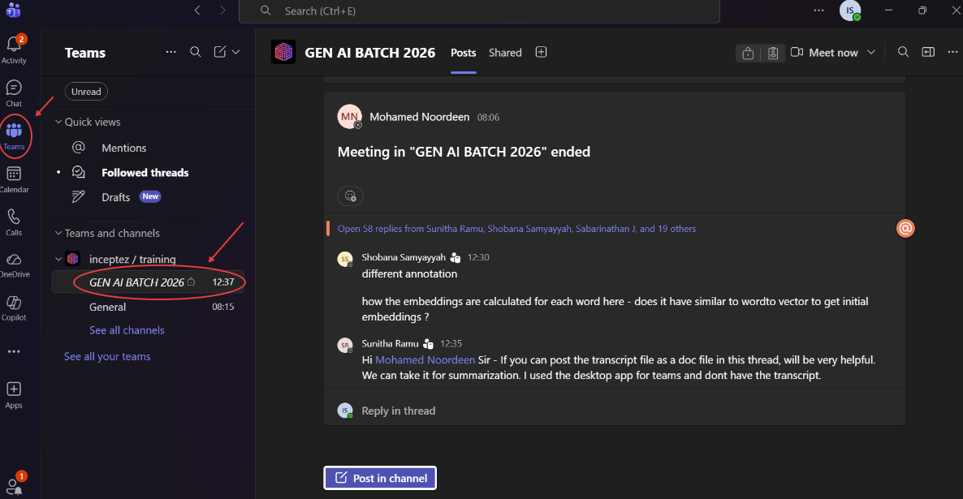

Step 3 : After clicking GEN AI BATCH 2026 , Click shared
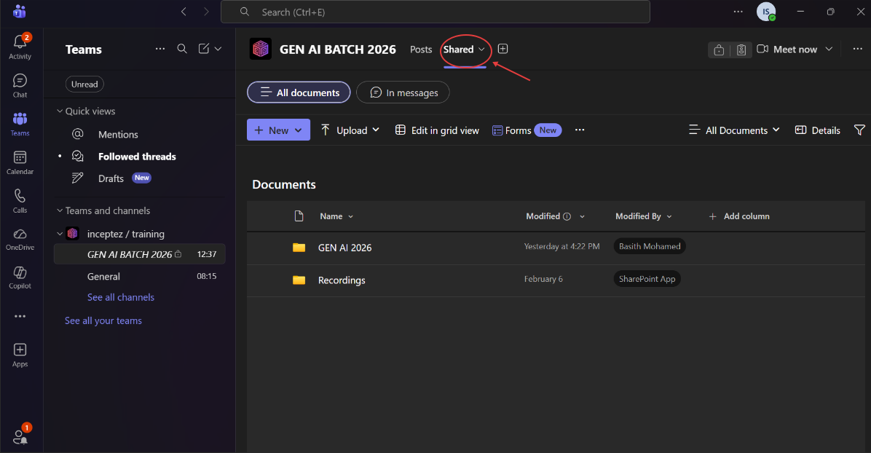

Step 4: After clicking shared below you can see the Folder name GEN AI 2026 , Click that folder.
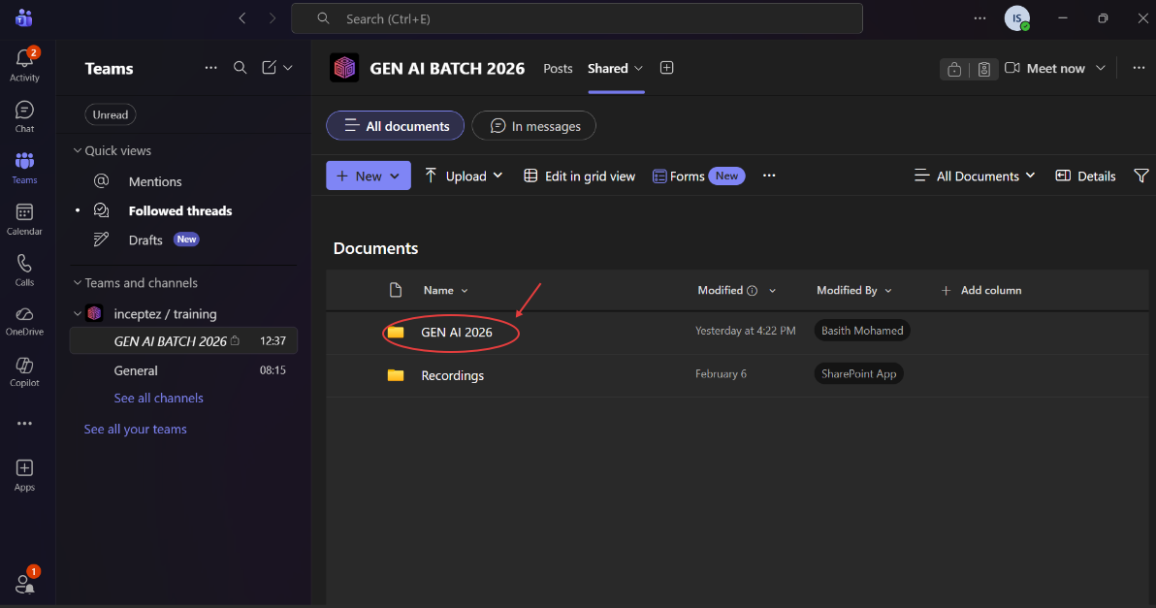

Step 5: Inside that folder you will see the another folder named with recording date, click that folder

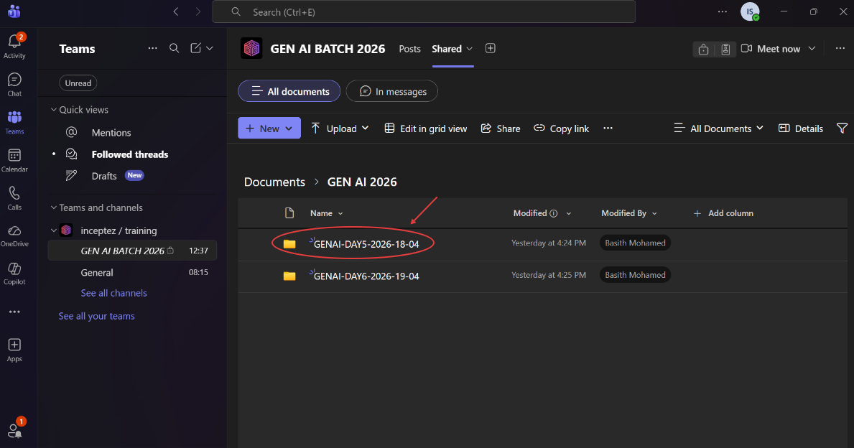

Step 6 : Inside that folder , click that recording to view

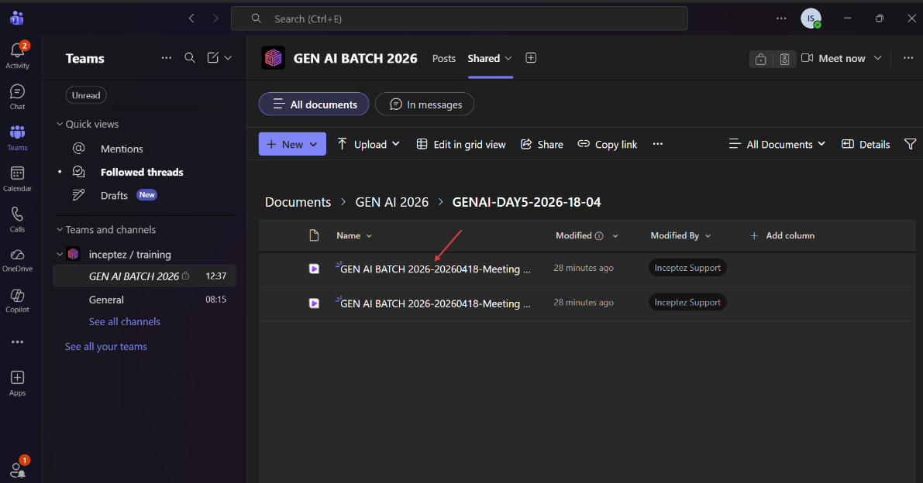

Step 7 : Now you can view the recording here
